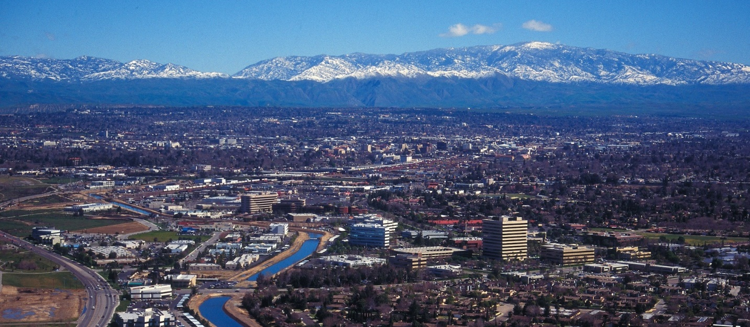
February 2022
The Communicator
KCCVARC Repeater Frequencies
145.150 | minus | 100.0 | Breckenridge Mt.
146.910 | minus | 100.0 | Grapevine Pk.
224,060 | minus | 100.0 | Breckenridge Mt.
443.900 | plus | 100.0 | Low level North of Town
52.780 | minus | 82.5 | Grapevine Pk. | Off the Air - Storm Damage

President: Vacant
1st VP: Dustin Carpenter, KC0AZW
2nd VP Larry Bragg, N6LWB
Secretary: Scott Royer, KM6RLD
Treasurer: John Stumm, KG6ZBN
Directors:
Paul Ball, KN6FVI
Glen Del Tour, WB8DTJ
Steve Holmes, KM6POI
Net Chief
Neal Janzen, N6YGG

January Meeting
The January meeting format changed a bit due to the lack of a quorum. For personal reasons some of the board members were unable to attend.
Many members took advantage of the time to reconnect with friends and welcomed some of the new members in the club.
Jerry, KB7BX, spoke at some length regarding a nifty 2 meter yagi using a tape measure for the elements and a hair pin matching system, realizing a 6db gain.
It was simple to construct and there were a couple of unique features in the construction that allowed the elements to be tucked away when not in use.
John, KG6ZBN, also brought a number of VHF and UHF antennas and shared some of the interesting features.
Included in his display was a Xiegu X6100, a very small, compact HF plus 6 meter transceiver that was a bit larger than an iPhone.
Among the multiple features were a 200k band width waterfall display, 7 inch touch screen, built in PSK, RTTY and CW modes. This QRP rig has 10w available using an external power source and 5w using the internal battery.
The rig would be a welcome addition to a go bag and would pair very nicely with a long wire, end fed antenna.
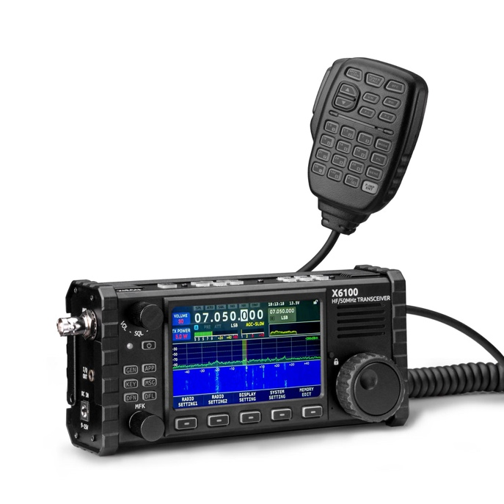

-BREAK-
HF Band Activity
For those of you who are interested in propagation, you might consider slipping over to 21383.00 around 1700 or 1800Z on week days. There is a group of hams from around the country who regularly check in and provide signal reports.
They group starts out on 12 meters for a time and then start moving up in frequency, hitting 15 meters, 17 meters and 10 meters. Some of the signals are very strong, depending on the conditions.
-BREAK-
From ARRL
The recent winter storm activity along the east coast saw volunteer radio amateurs across New England get down to business early January, as a major winter storm and blizzard dropped up to several feet of snow.
Wet snow and damaging winds felled trees and power lines in coastal portions of eastern Massachusetts, particularly in Cape Cod and the Islands. More snow events also occurred in early February.
The New England Reflector, an Internet Radio Linking Project (IRLP), relayed many SKYWARN reports. Close to a dozen repeaters hosted rolling amateur radio SKYWARN nets. Digital Mobile Radio (DMR) was utilized for SKYWARN efforts.
The efforts of your east coast ham brothers and sisters demonstrate once again what we are capable of when Mother Nature reminds us all of who is in charge.
ARRL Code Practice
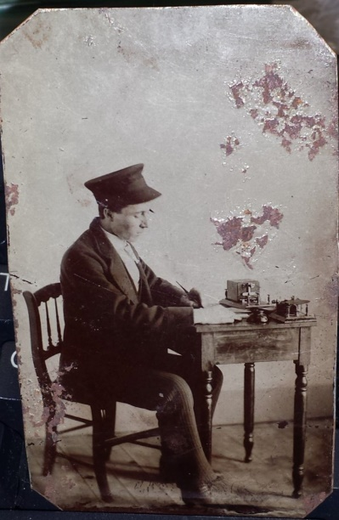
ARRL has made practice sessions available for those for who someday has arrived. If you are interest you can find W1AW on these frequencies at 1300, 1600 and 1900 local time
Frequencies are 1.8025, 3.5815, 7.0475, 14.0475, 18.0975, 21.0675, 28.0675, 50.350, and 147.555 MHz.
Slow Code = practice sent at 5, 7-1/2, 10, 13 and 15 words per minute (wpm).
Fast Code = practice sent at 35, 30, 25, 20, 15, 13 and 10 wpm. Code bulletins are sent at 18 WPM.
-BREAK-
Winter Field Day
The ARRL winter field day took place over January 29 and 30. A quick search on the bands suggested that the activity was somewhat anemic. This was confirmed in a conversation with Dustin Carpenter, KC0AZW, who reported that contact pickin’s were slim.
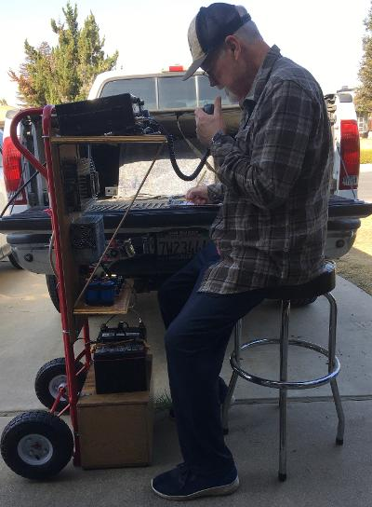
John, KG6ZBN, seeking out contacts
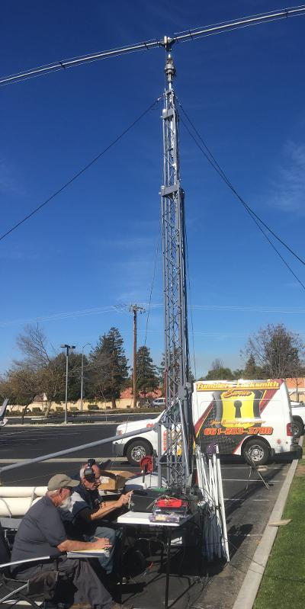
Portable antenna set up
John Stumm, KG6ZBN, and Thurman Van de Mark, WB6NJC, set up in the parking lot of a local church, seeking out what contacts they could. The bands were pretty quiet due to unfavorable conditions, according to John.
The pair was able to make contacts in Canada and the Eastern Seaboard. They made 10 or 12 contacts. Thurman was trolling 15 meters, while John focused on 20 or 40 meters.
John chatted with a ham that had just moved into the area. He had been looking for help in setting up his new station. There is an effort underway to assist with the set up.
-BREAK-
Western Kern County ARES
Western Kern County ARES holds a net on the W6LIE repeater on 145.150 at 1900 local time, Monday evenings. The participants will move off to simplex frequencies in order to test the effectiveness and range of simplex communications.
ARES is open to amateur radio operators interested in supporting their community in times of emergencies. If you are interested in participating, check in on the net. There is also an application available on the W6LIE web site.
For more information about ARES please send an email to WKCARES@GMAIL.COM.
-BREAK-
Upcoming Events
The February meeting is scheduled for the 24th of February. The board will meet at 6:30pm, prior to the general meeting. The meeting will be held at the Veteran’s Hall on Ridge Road.
VE testing - Mark March 11 on your calendar if you are planning to obtain your license or upgrade. Contact Larry Callahan, KF6JOQ for more information. If you would like to test on another date, please contact Larry and he may be able to make arrangements for an earlier date.
-BREAK-
Looking for Stuff!
Hey! Bet you didn’t know that you have an editorial staff for The Communicator, did ya! Currently it is a staff of one. But we have members out there that might have a topic or two that could be of interest to the membership.
So if you have an article you would like to submit or photos from past or current events please let me know and we can set them up for publishing. This is your newsletter. It should reflect the interests of the members.
73!
-BT-

