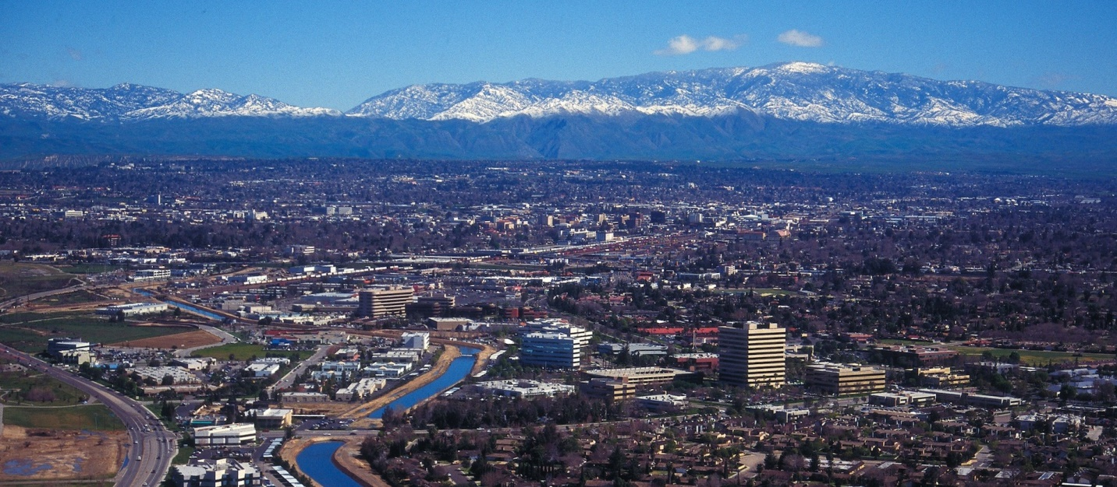
January, 2021
The Communicator
KCCVARC Repeater Frequencies
145.150 | minus | 100.0 | Breckenridge Mt.
146.910 | minus | 100.0 | Grapevine Pk.
224,060 | minus | 100.0 | Breckenridge Mt.
443.900 | plus | 100.0 | Low level North of Town
52.780 | minus | 82.5 | Grapevine Pk. | Off the Air - Storm Damage

President: Vacant
1st VP: Dustin Carpenter, KC0AZW
2nd VP Larry Bragg, N6LWB
Secretary: Scott Royer, KM6RLD
Treasurer: John Stumm, KG6ZBN
Directors:
Paul Ball, KN6FVI
Glen Del Tour, WB8DTJ
Steve Holmes, KM6POI
Net Chief
Neal Janzen, N6YGG

Meet the 2022 Board
2022 is here and we have a new Board of Officers and Directors.
President – vacant
1st VP – Dustin Carpenter
Dustin Carpenter, a Bakersfield native, was elected to the position of 1st Vice President. In addition to his activities with the club and ARES, he is employed by Biscuit Downtown Grooming. He discovered ham radio through a friend. Dustin worked FRS using gear borrowed from his friend. He was first licensed in 1997 and spends a lot of time on 2 meters. He obtained his General and has been exploring HF. He participated in Field Day for the first time last year and is looking forward to chasing satellites and working DX.
2nd VP – Larry Bragg
Larry, a Bakersfield native, graduated from Foothill High School in 1974 and went on to Bakersfield College that same year, studying Computer Sciences.
He graduated in 1979 and continued his studies with National Training Institute focusing on Computer Sciences. He also took some computer classes at Cal State Bakersfield.
For 21 years Larry worked at the Bakersfield Californian and after retiring he worked in sales for Radio Shack and developed programs for Radio Shack scanners.
Larry was first licensed as a novice in 1978. He admitted that he wasn’t very active as a novice and it wasn’t until 1987 he obtained his technician’s license.
He recounted his time with Roger Eerez, N6HPH and Red Coulter, WB6DWG and credited them as mentors and administering the test.
He said his interests span a broad range, including short wave listening, his earliest experiences with radio. He is currently exploring digital radio and, much like a large part of the population in general, sought out videos on YouTube, learning how to develop programs and code plugs.
Larry previously served on the board around 1990, in various positions. He will bring his experience to the 2022 board.
Scott Royer – Secretary
Even though Scott was born at the Great Lakes Training Center, he was not destined for the sea. The family moved to California and Scott graduated from Camarillo High School in 1992.
Cal State Bakersfield was where he continued his education, graduating in 1997. Prior to graduation, Scott took a position with Kern County Probation Department in 1996, where he is currently employed.
As a youngster, Scott was introduced to Amateur radio through a family friend. Contact was made with the space shuttle and that event made an impact.
Pairing up with Steve Holmes, Scott and Steve took the test in 2018 and received their technician’s ticket.
You can find Scott on 2 meters. He also works digital modes. He has his eye on a General and has been listening to HF.

John Stumm – Treasurer
Before retiring10 years ago, John was an instrumentation and controls tech for Southern California Edison, working in power plants and switch yards.
Born in Bakersfield, he spent his formative years in Long Beach. He made his home in Bakersfield 35 years ago. In 2005, John obtained his ham license but admitted that he was not very active until after he retired.
He said he has always been interested in radio and electronics and has recently devoted his energy into building and experimenting with antennas and making and selling BALUNs and UNUNs for HF, some of his own design.
He has all-band capability and tests his designs using a long wire. John checks into a variety of nets on 20, 40 and 80 meters and is an ARES area control on 6 and 10 meters.

Paul Ball, Director
Paul is another Bakersfield native. He attended North High, graduating in 1996. He later attended Bakersfield College, where he obtained an Associate’s degree in Industrial physiology.
He started working for Univision in 1996 and obtained a BS degree in software design while employed there.
Paul said that his supervisor and co-workers were involved in amateur radio and encouraged him to obtain his license. He was first licensed in 2019 as a technician.
He admits that he is a bit hesitant when it comes to talking on the radio and confines his activities to 2 meter simplex.
Steve Holmes, - Director
Steve is another Bakersfield native. He attended West High, graduating in 1989. He attended Cal State, Humboldt and returned to Bakersfield, taking classes at Cal State, Bakersfield.
He became a reserve officer with the Bakersfield Police Department and pursued a career in law enforcement, joining the University Police Department. He recently retired last November.
Steve was first licensed in 2018 as a technician. He has set a goal, planning to obtain his general ticket this year.
Ham radio is a fun hobby, according to Steve. He enjoys talking to other hams on 2 meters and works some digital modes.

Glen Del Tour – Director
Glen is a retired investigator for a large insurance company and continues to teach martial arts. Originally from San Jose, he moved to Bakersfield in time to experience the 1952 earthquake.
In high school he developed an interest in radio and, with his brother, built a CB radio. He served in the Navy, where he learned CW and communication protocols.
After serving in the Navy, he moved to Michigan and received a ham license in 1968. He is generally on 20 or 40 meters and is a member of ARES.

VE Results
January 14 was the date of the latest round of VE testing. Three people attended, three people tested and three passed. The new Hams are:
Richard Schneider, upgrading to General; Calvin Fields, passed the technician and General; Ronald Hollar, passed General and Extra.
Congratulations to them. Make sure to acknowledge their achievement when you encounter them on the air.
_____________________________________
ARRL CW Practice Schedule
ARRL has made practice sessions available for those for who someday has arrived. If you are interest you can find W1AW on these frequencies at 1300, 1600 and 1900 local time
Frequencies are 1.8025, 3.5815, 7.0475, 14.0475, 18.0975, 21.0675, 28.0675, 50.350, and 147.555 MHz.
Slow Code = practice sent at 5, 7-1/2, 10, 13 and 15 words per minute (wpm).
Fast Code = practice sent at 35, 30, 25, 20, 15, 13 and 10 wpm.
Code bulletins are sent at 18 wpm.

Big Wind and Rain in the Big Valley
Most of the time the weather in Bakersfield is pretty uneventful. The temperature during the summer can be counted on to exceed 90 or 100 degrees. Often summer bleeds into fall and will pass unnoticed for the most part.
Spring lasts about two weeks and flows into summer in a similar manner and usefulness as the appendix in human anatomy.
But then there is winter. Unpredictable is winter’s name and just like a wild boar hog likely to turn and strike with tusk or fang. The winds blow, hard, hard enough to bring down fences, trees and scattering roofing shingles across the yard like wind born fall leaves.
Then comes the rains. The ground is saturated to the point that small lakes and rivers sprout in the most unlikely places.
During heavy rain fall the front yards of homes in local neighborhoods more closely resemble Louisiana swamps and bayous, lacking only ‘gators and cotton mouth snakes to complete the picture.
To add to the chaos, trees, most times firmly clutching the ground with robust roots, standing proudly as sentinels providing shade and shelter during the high days of summer, begin to turn like a junk yard dog.
They shed branches in the wind with no concern for the mayhem that results. And when you least expect it, trees will topple over like a set of pins blasted by a well-aimed 16-pound bowling ball.
They never land harmlessly, draping themselves across the yard like a silent movie heroine dropping onto a convenient fainting couch. No, no. They, with malicious intent, aim for the most vulnerable, the most exposed portion of the manor they can find. Like the harmless antenna, dealing with its own issues, swaying in time with the 20 or 30 MPH gusts.
In the aftermath of the storm it becomes necessary to assess the damage and wonder what to do with the tree that was so lovingly planted in the hopes of sharing comfort and shade from the summer heat. And then there is the matter of the antenna, lying in a ruinous heap.
As if the demise of the tree wasn’t enough, there is the discovery that saw, neither powered nor manual will make a dent in the palm tree that is now horizontal.
One stroke, maybe two and the fibers cling to the blade in the same manner of a barnacle clutching the hull of a ship. But the tree does succumb to the sharp blade of an axe. Fury at the damaged antenna lends strength to the blows.
The cleanup ends, the antenna, once again, stands tall and proud, proclaiming to all who can see, this is the domicile of a ham operator. And all is once again well with the world. CQ DX
ARES
Western Kern County ARES has a regularly scheduled net on the W6LIE repeater on 145.150 at 1900 local time, Monday evenings. The participants will then move off to simplex frequencies in order to test the effectiveness and range of simplex communications.
ARES is open to amateur radio operators interested in supporting their community in times of emergencies. If you are interested in participating, check in on the net. There is also an application available on the W6LIE web site.
For more information about ARES please send an email to WKCARES@GMAIL.COM
Check it out!

Upcoming Events
January meeting – The first general meeting will be held on January 27th at 7:30pm. The meeting will be held at the Veteran’s Hall on Ridge Road.
VE testing - Mark March 11 on your calendar if you are looking to obtain your license or upgrade. Contact Larry Callahan, KF6JOQ for more information. If you would like to test on another date, please contact Larry and he may be able to make arrangements for an earlier date.
Check in with John, KG6ZBN, if you are interested in participating in the Winter Field Day. Set for January 29, Winter Field Day is seeing a big increase in participation. The cool weather is a definite draw here in Bakersfield.
______________________________

Looking for Stuff!
Hey! Bet you didn’t know that you have an editorial staff for The Communicator, did ya! Currently it is a staff of one. But we have members out there that might have a topic or two that could be of interest to the membership.
So if you have an article you would like to submit or photos from past or current events please let me know and we can set them up for publishing. This is your newsletter. It should reflect the interests of the members.
73!
-BT-

