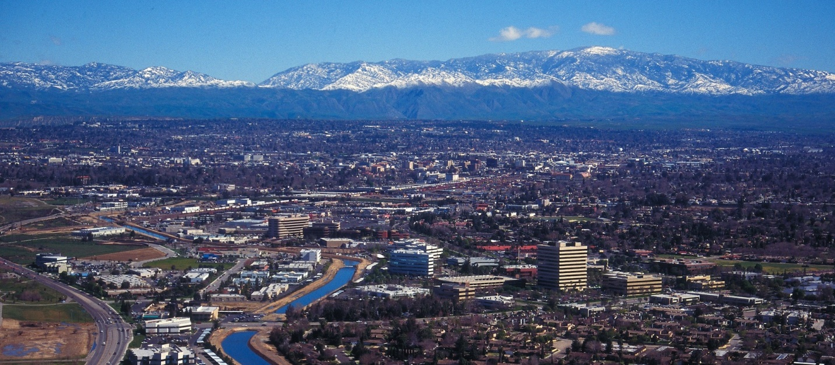
July 2022
The Communicator
KCCVARC Repeater Frequencies
145.150 | minus | 100.0 | Breckenridge Mt.
146.910 | minus | 100.0 | Grapevine Pk.
224,060 | minus | 100.0 | Breckenridge Mt.
443.900 | plus | 100.0 | Low level North of Town
52.780 | minus | 82.5 | Grapevine Pk. | Off the Air - Storm Damage

President: Larry Callahan KF6JOQ
1st VP: Dustin Carpenter, KC0AZW
2nd VP Larry Bragg, N6LWB
Secretary: Scott Royer, KM6RLD
Treasurer: John Stumm, KG6ZBN
Directors:
Paul Ball, KN6FVI
Glen Del Tour, WB8DTJ
Steve Holmes, KM6POI
Net Chief
Neal Janzen, N6YGG

June Field Day
ARRL Field Day is usually an eagerly awaited annual event. Clubs and individual operators spend time prior to the kick off practicing and preparing for the big day.
Traditionally our June board and general meeting is canceled in favor of Field Day. And this year was no exception. Stations were set up in College Park and the requests for contacts flying fast and furious.
John Stumm, KG6ZBN, oversaw the activities this year. There was a total of 6 stations, with a total of 30 contacts.
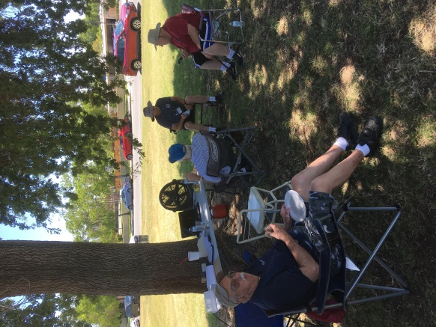
John, KG6ZBN, found shade to set up his station. Sharing the shade with John are Don Pettric, WG6H and Arly, N6INT, and his out of town friends.
The bands were uncharacteristically quiet this year. Generally HF frequencies are wall to wall operators gathering as many contacts as possible.
15 meters is often a gold mine for unique contacts. But a run through the band this year did not yield much.
John has submitted the totals to ARRL and the results of the 2022 Field Day are pending.
-BREAK-
From ARRL
2022 ARRL Field Day wrapped up nearly a week ago, and ARRL Headquarters has already received over 2,400 entries submitted via the online Field Day Entry web application.
As of June 29, the breakdown of Field Day entries by Class showed 2,723 total entries, with 272 in Class A, 361 in Class B, 32 in Class C (mobile), 1,524 in Class D, 484 in Class E, and 50 in Class F.
So far, a total of over 517,000 contacts were reported for the event and those numbers are changing daily. In 2021, there were 1.5 million contacts made during Field Day activities.
Many participants were keeping their hopes up for better propagation, as early forecasts were looking promising. ARRL Contest Program Manager Paul Bourque, N1SFE, said, "While band conditions might not have been the greatest, there was a good amount of activity on the bands this past weekend."
-BREAK-
Silent Keys
We are saddened by the news of the passing of two fellow Hams, Dar Reisinger K6KNK, who passed on July 4, and Rick Schneider KD6KZA, who passed away on May 25.
If you would like to share your memories of Dar and Rick, please forward them to Glen, WB8DTJ and we will publish them in the August Communicator.
-BREAK-

Tehachapi Earthquake, 70 years.
The 70th Anniversary of the 1952 quake will be commemorated with a special one day event with special 1X1 call signs under the control of Terry Godley, N6AJ. According to Terry there will be several stations involved using call signs, K6B through K6L.
Participating operators will use CW, FT8 FT4, satellite connections and will be transmitting on all HF bands, as well as local repeaters. A commemorative QSL card will be sent out to those making contact.
The story began on July 21, 1952 when a 7.3 earthquake struck the White Wolf fault. The fault runs in a northwesterly direction between Bakersfield and Tehachapi. At 0430 the fault came alive, causing millions of dollars of damages. 12 people lost their lives and hundreds were injured.
Many of those injured fled from the interior of buildings only to be struck by falling debris. A number of changes in the building codes resulted from the failure of unreinforced masonry.
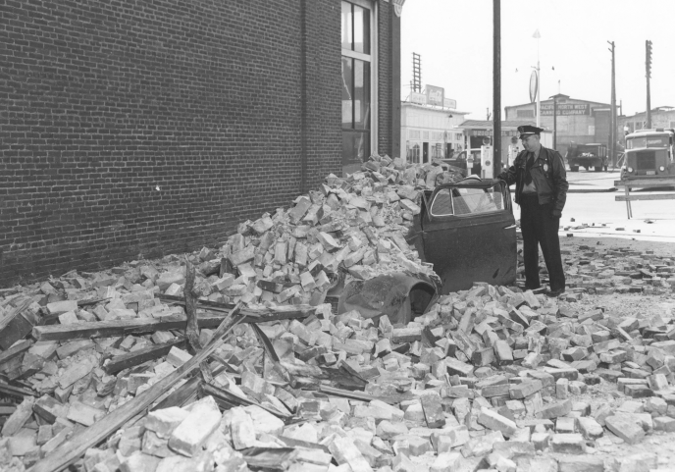
The event is permanently impressed on the memories of those who lived through the quake. People slept out of doors for fear of structural failure and collapse. The smell of insect repellant permeates the memory of those nights.
Look for a special event station near you.
-BREAK-
ARRL Code Practice
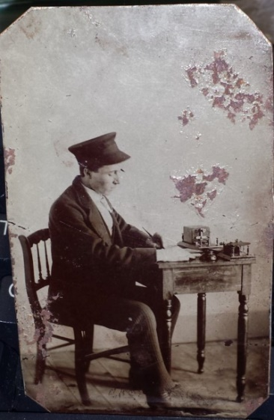
For those of you who would like to dip a toe into CW, ARRL has practice sessions available. If you are interest you can find W1AW on these frequencies at 1300, 1600 and 1900 local time.
Frequencies are 1.8025, 3.5815, 7.0475, 14.0475, 18.0975, 21.0675, 28.0675, 50.350, and 147.555 MHz.
Slow Code = practice sent at 5, 7-1/2, 10, 13 and 15 words per minute (wpm).
Fast Code = practice sent at 35, 30, 25, 20, 15, 13 and 10 wpm. Code bulletins are sent at 18 WPM.
-BREAK-
Western Kern County ARES
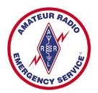
Western Kern County ARES holds a net on the W6LIE repeater on 145.150 at 1900 local time, Monday evenings. The participants will move off to simplex frequencies in order to test the effectiveness and range of simplex communications.
The third Monday of the month ARES stations will be directed to a specific area control’s assigned frequency. The planned operation for June was postponed and will take place on July 18. The focus will be on portable operations, including radios, power supplies and antennas.
A control station will be positioned on the Bluffs, fielding contact with ARES members and other operators in the Metro Bakersfield area.
The exercise is intended to determine the effectiveness of portable equipment during simulated emergency conditions
There have been some good results using 2 meter SSB. Contacts during the net seem to support the reliability of VHF SSB. Stations that have that capability are invited to join during the net. The frequency for 2 meter SSB is 144.225 upper sideband.
The search is still on for folks willing to operate at net control. If you are interested advise net control during the Monday evening net or forward an email to KC6EOC@gmail.com
ARES is open to amateur radio operators interested in supporting their community in times of emergencies. If you are interested in participating, check in on the net. There is also an application available on the W6LIE web site.
For more information about ARES please send an email to WKCARES@GMAIL.COM.
-BREAK-
Heard on the Band
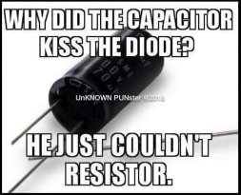
An elderly ham driver was going down the interstate when suddenly his 2 meter rig crackled his call…Answering…he heard a fellow ham’s urgent warning…..”Hey Jim, just heard on the news that there’s a car going down I-35 the wrong way, please be careful”!!
Jim replied, “I got news for ya!. It’s not just one…….there’s hundreds of them’!!!!!!!!!
Upcoming Events
The July meeting is scheduled for the 28th, at the Veteran’s Hall on Ridge Road. The board will meet at 6:00pm, with the general meeting to follow. The general meeting is scheduled to begin at 7:00PM.
If you are looking for something to do, check out the special event called Meme Appreciation Month. The event runs until August 5 and is on all bands, all modes.
Look for K3K, VB3HARAMBE, VB4LIGMA, VB3YEET, VB6DANK, VC3DEEZ, VC3RIKROLL AND VC9CATGIRL.
(Editor’s note- I suspected the call signs were someone’s idea of a gag but I did check QSL’s web page and was able to pull up a listing for them. Sounds like it might be fun.)
VE testing will be offered in September. For more information please contact Larry Callahan, KF6JOQ. If you would like to test on another date, please contact Larry and he may be able to make arrangements for an earlier date.
-BREAK-

Looking for Stuff!
Hey! Bet you didn’t know that you have an editorial staff for The Communicator, did ya! Currently it is a staff of one. But we have members out there that might have a topic or two that could be of interest to the membership.
So if you have an article you would like to submit or photos from past or current events please let me know and we can set them up for publishing. This is your newsletter. It should reflect the interests of the members.
73!
-BT-

