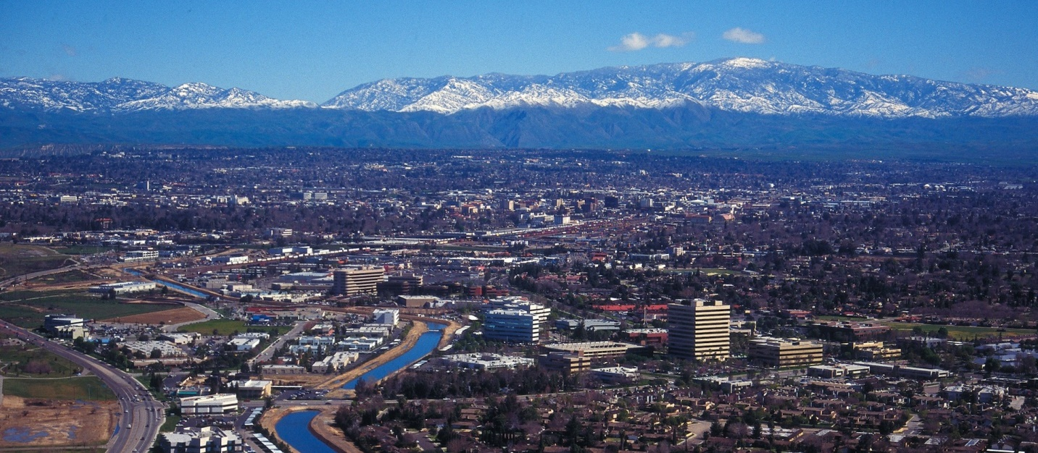
June 2022
The Communicator
KCCVARC Repeater Frequencies
145.150 | minus | 100.0 | Breckenridge Mt.
146.910 | minus | 100.0 | Grapevine Pk.
224,060 | minus | 100.0 | Breckenridge Mt.
443.900 | plus | 100.0 | Low level North of Town
52.780 | minus | 82.5 | Grapevine Pk. | Off the Air - Storm Damage

President: Larry Callahan KF6JOQ
1st VP: Dustin Carpenter, KC0AZW
2nd VP Larry Bragg, N6LWB
Secretary: Scott Royer, KM6RLD
Treasurer: John Stumm, KG6ZBN
Directors:
Paul Ball, KN6FVI
Glen Del Tour, WB8DTJ
Steve Holmes, KM6POI
Net Chief
Neal Janzen, N6YGG

May Meeting
The May meeting was held at the Veteran’s Hall. The topic of discussion was Field Day, coming up on the 25th.

John is the coordinator for this year’s event. He gave a slide presentation on the topic. A show of hands of those who might be attending suggested several were interested.

So far only 4 have responded to emails. The hope is that it picks up. Please contact John if you are interested and would like more details.

A raffle rounded out the activities. Larry Callahan, KF6JOQ, won a gift certificate valued at $150.00
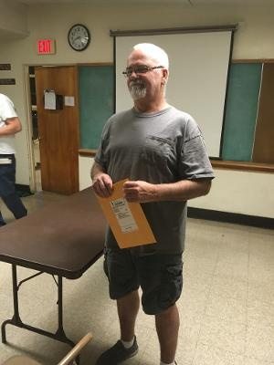
Don Pettric, WG6H, snagged the Nano VNA antenna analyzer.
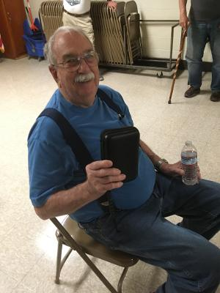
Congratulations to the raffle winners!
Submitted by John, KG6ZBN.

-BREAK-
Ham shack
This month we are featuring the shack of Jerry Waclawski, KB7BX.

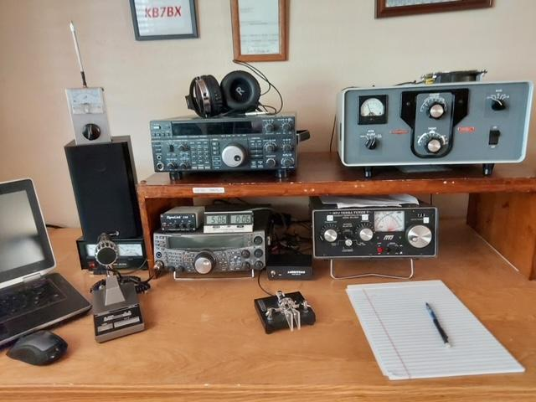

Jerry described the items in his layout. There is a Dell Laptop on the left, an MC-60 microphone, with a power supply and receiver speaker behind the mic.

A Kenwood TS-2000 is located under the shelf and a Kenwood TS-850 on the top shelf.
There's a Signal Link USB interface between the TS-2000 and the laptop. FT8 is available through the link. The laptop can also be used to decode 35WPM+ CW.

Featured on the right of the TS-2000 is a MFJ antenna tuner. On the top shelf on the right is a Collins 30L1 1000 watt amplifier. Jerry usually runs about 750 watts on SSB and about 450 watts on CW.

The station is serviced by a horizontal 75meter loop that's about 10 feet off the ground. It's an NVIS antenna that radiates straight up. The signal hits the D or F1 layer and sprays down
about 500 miles around his QTH.
This set up allows coverage for all of California, Oregon, Washington, Idaho, Nevada, Arizona, and parts of West Texas. But it is not the best for DX.

Plans for the near future are for the installation of a new vertical. The hope is for coverage for all the bands, from 40 through 10.meters.

Thanks to Jerry for the photo and description of his shack. It is a very nice, clean layout.

-BREAK-
From ARRL
Field Day is ham radio's open house. Every June, more than 40,000 hams throughout North America set up temporary transmitting stations in public places to demonstrate ham radio's science, skill and service to our communities and our nation.
It combines public service, emergency preparedness, community outreach, and technical skills, all in a single event. Field Day has been an annual event since 1933, and remains the most popular event in ham radio.
There is a contest component of Field Day. The goal is to simply contact as many other stations as possible. A secondary part is the opportunity to learn to operate radio gear under abnormal situations and less than optimal conditions.
We use these same skills when we help with events such as marathons and bike-a-thons; fund-raisers such as walk-a-thons; celebrations such as parades; and exhibits at fairs, malls and museums — these are all large, preplanned,
non-emergency activities.
Despite the development of very complex, modern communications systems — or maybe because they ARE so complex — ham radio has often been called upon to provide emergency communications. Operators provide communications in crises when it really matters.
Amateur radio operators are well known for communications support in real disaster and post-disaster situations.
Please contact John, KG6ZBN, if you plan to operate during this year’s Field Day. You can designate your contacts as part of W6LIE’s efforts. See John for more information.
-BREAK-
ARRL Code Practice
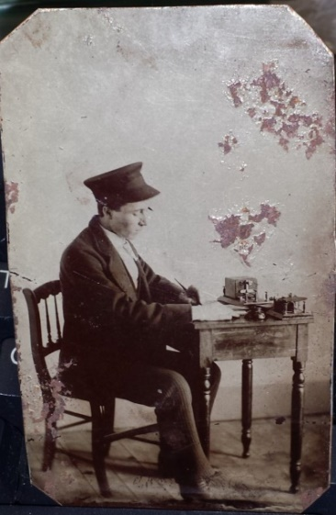
CW is time tested and could be considered the very first digital mode. Instead of ones and zeros CW uses dots and dashes.
There is a lot of CW activity on the bands. Many hams are using automatic keyers and the like but for those of us who plod along at around 10 or 13 WPM, there are plenty of people who will respond to your CQ. Give it a try!
ARRL has made practice sessions available for those for who someday has arrived. If you are interest you can find W1AW on these frequencies at 1300, 1600 and 1900 local time.
Frequencies are 1.8025, 3.5815, 7.0475, 14.0475, 18.0975, 21.0675, 28.0675, 50.350, and 147.555 MHz.
Slow Code = practice sent at 5, 7-1/2, 10, 13 and 15 words per minute (wpm).
Fast Code = practice sent at 35, 30, 25, 20, 15, 13 and 10 wpm. Code bulletins are sent at 18 WPM.
-BREAK-

Western Kern County ARES
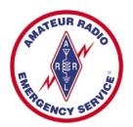
Western Kern County ARES holds a net on the W6LIE repeater on 145.150 at 1900 local time, Monday evenings. The participants will move off to simplex frequencies in order to test the effectiveness and range of simplex communications.
The third Monday of the month ARES stations will be directed to a specific area control’s assigned frequency. This month ARES will be focusing on portable equipment, including radios, power supplies and antennas, in an effort to determine the effectiveness of equipment in less than optimal conditions.
The 2 meter SSB may be part of this test, depending on the capabilities of participating stations. The frequency is 144.225 upper sideband.
A recent net revealed an issue regarding net control. All of the net control stations were unavailable. Richard, KK6RJR, stepped up and acted as net control.
We are still looking for folks willing to operate at net control. If you are interested advise net control during the Monday evening net or forward an email to KC6EOC@gmail.com
ARES is open to amateur radio operators interested in supporting their community in times of emergencies. If you are interested in participating, check in on the net. There is also an application available on the W6LIE web site.
For more information about ARES please send an email to WKCARES@GMAIL.COM.
-BREAK-

Heard on the Band
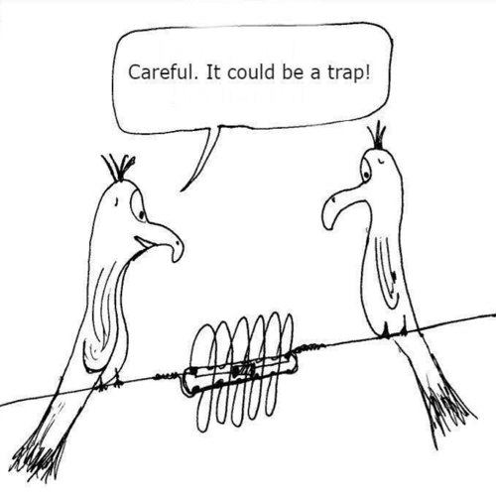
Ray & Bubba (Tennessee mechanical engineers and ham radio operators) were standing at the base of a flagpole, looking up and trying to figure out the best way to make a 20 meter stealth vertical out of it.
A plumber happened by and asked the duo what they were doing. "We're supposed to find the height of the flagpole," said Bubba, "but we don't have a ladder."
The plumber took a wrench from his tool box, loosened a few bolts, and laid the flag pole down.
Then he took a tape measure from his pocket, took a measurement, announced, "Eighteen feet, six inches," and walked away.
Ray shook his head and laughed. "Ain't that just like a plumber? We ask for the height and he gives us the length!"
Bubba and Ray are currently working for the federal government designing totally invisible towers for long range communications.
They are experiencing great difficulty in seeing the tower sections and putting them together!

Upcoming Events
The June meeting is replaced by Field Day. Please join us on June 25th at College Park located at Mt Vernon and Panorama Dr. Set up starts at 0900 and the event kicks off at 1100.
VE testing will be offered July 8. For more information please contact Larry Callahan, KF6JOQ. If you would like to test on another date, please contact Larry and he may be able to make arrangements for an earlier date.
-BREAK-
Looking for Stuff!
Hey! Bet you didn’t know that you have an editorial staff for The Communicator, did ya! Currently it is a staff of one. But we have members out there that might have a topic or two that could be of interest to the membership.
So if you have an article you would like to submit or photos from past or current events please let me know and we can set them up for publishing. This is your newsletter. It should reflect the interests of the members.
73!
-BT-

