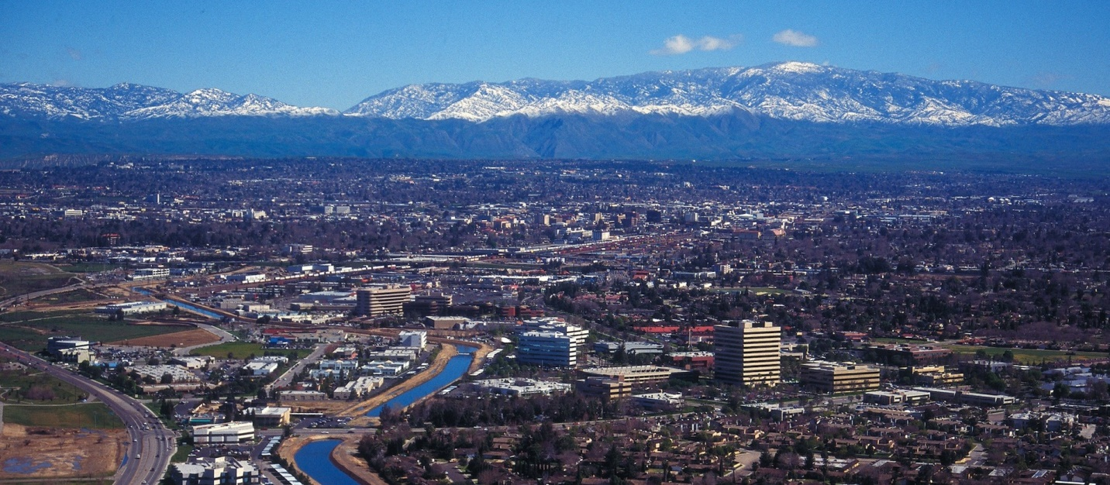
March 2022
The Communicator
KCCVARC Repeater Frequencies
145.150 | minus | 100.0 | Breckenridge Mt.
146.910 | minus | 100.0 | Grapevine Pk.
224,060 | minus | 100.0 | Breckenridge Mt.
443.900 | plus | 100.0 | Low level North of Town
52.780 | minus | 82.5 | Grapevine Pk. | Off the Air - Storm Damage

President: Larry Callahan KF6JOQ
1st VP: Dustin Carpenter, KC0AZW
2nd VP Larry Bragg, N6LWB
Secretary: Scott Royer, KM6RLD
Treasurer: John Stumm, KG6ZBN
Directors:
Paul Ball, KN6FVI
Glen Del Tour, WB8DTJ
Steve Holmes, KM6POI
Net Chief
Neal Janzen, N6YGG

February Meeting
The February Board meeting did not address any business due to the lack of a quorum. A number of topics were discussed but no action was taken.
Dustin Carpenter, the 1st Vice President, used his authority to appoint Larry Callahan, KF6JOQ to the position of president.
Board approval is not required by the bylaws, but some of the board members offered some input regarding the appointment. Larry has accepted the position and will fill the vacancy until the next election.
The idea of holding a meeting in a pizza palor had been one of the topics under discussion. There was also a need for additional net controllers. This seems to be an issue in the area, as other groups, including ARES, are looking for people to assume the reins.
The general meeting was sparsely attended. Three raffle prizes were available. A Yaesu FT-4XR was won by Richard, KD6KZA. Frederic donated two Baofeng hand held for the raffle. Larry, KF6JOQ and Ron Hollar, KD6ROH, were the lucky winners.
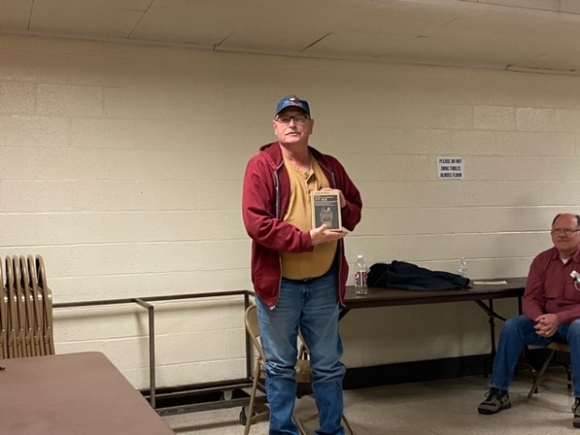
-BREAK-

HF Band Activity
A contest was held over the March 4th weekend. A check of 15 meters revealed a lot of activity. There were quite a few DX stations on the air, including some from South America and Spain.
Other local stations were heard making contact with European countries. There were also a number of Japanese stations in the mix.
15 meters might be the band that you want to check on if you are looking for DX contacts.
-*-
News From Europe
The invasion of Ukraine by Russia prompted Ukraine’s legislative body to issue a state of emergency, including commercial radio and TV stations, as well as a ban on amateur radio stations.
IARU subsequently issued a short statement: “IARU is an apolitical organization focused on promoting and defending amateur radio and the amateur radio services. The Amateur Radio Service is about self-instruction in communications and friendship between people.”
The DARC HF Committee issued this statement on February 27: “Any radio amateur currently transmitting from Ukraine is risking his or her life. If you hear a Ukrainian station, do not broadcast its call sign, location, or frequency — whether on the band, in a cluster or on social media. You may be putting lives at risk.”

-BREAK-

From ARRL

Sometimes it is so easy to forget where you are in the band, especially if you are contesting near the edge of the band. But you never know who may be watching.
Many of the Advisory Notices sent out each month by the ARRL Volunteer Monitor Program go to stations heard operating outside the operator’s license privileges.
Typical cases often involve operators holding Technician- or General-class amateur licenses being heard on a frequency or band not permitted by their license privileges.
Most recent incidents have frequently entailed FT8 digital mode operation by Technician licensees on 20 and 40 meters. Technician licensees do not have any operating privileges on 20 meters.
If you are unsure about where your privileges are on the band, ARR has a convenient chart on its website that details privileges available to all license classes, from Novice to Amateur Extra.
General-class operators have lost their way on some bands too, and Advisory Notices have gone out to those operating outside of the General-class phone subbands.
Technician- and General-class licensees may operate CW on any subband on which they have operating privileges, although operation within the CW subbands is preferred by band plan.
ARRL Code Practice
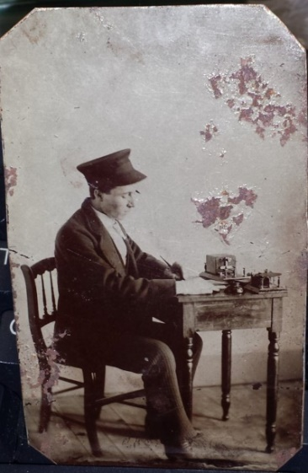
ARRL has made practice sessions available for those for who someday has arrived. If you are interest you can find W1AW on these frequencies at 1300, 1600 and 1900 local time
Frequencies are 1.8025, 3.5815, 7.0475, 14.0475, 18.0975, 21.0675, 28.0675, 50.350, and 147.555 MHz.
Slow Code = practice sent at 5, 7-1/2, 10, 13 and 15 words per minute (wpm).
Fast Code = practice sent at 35, 30, 25, 20, 15, 13 and 10 wpm. Code bulletins are sent at 18 WPM.
-BREAK-
Western Kern County ARES
Western Kern County ARES holds a net on the W6LIE repeater on 145.150 at 1900 local time, Monday evenings. The participants will move off to simplex frequencies in order to test the effectiveness and range of simplex communications.
At the end of February ARES experimented with the effectiveness of simplex frequencies involving the entire group. The idea was to use relays where needed and determine the range of simplex in the Greater Bakersfield area. Although there were some areas that were in a radio shadow, some stations in Kern River Valley were able to make contact.
Another area of discovery was the limitations places on hand helds. Using the rubber ducky antenna limits the effective range. The addition of an external antenna increases the range exponentially
There are a number of simple DIY projects for home brew 2 meter antennas that are inexpensive and easy to assemble. An adapter is needed to accommodate the connection from the antenna to the radio. . Here is a photo of an inexpensive homebrew 2 meter dipole.
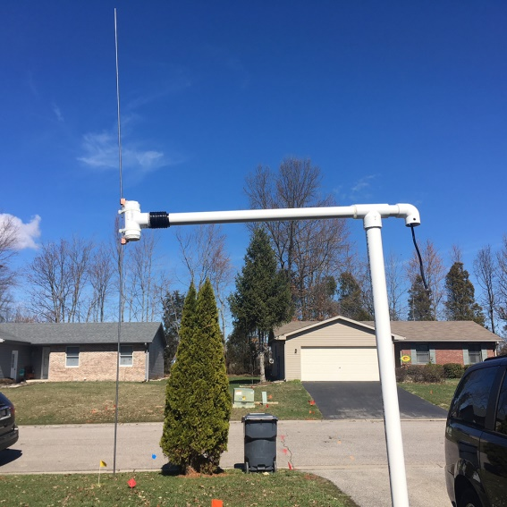
ARES is open to amateur radio operators interested in supporting their community in times of emergencies. If you are interested in participating, check in on the net. There is also an application available on the W6LIE web site.
For more information about ARES please send an email to WKCARES@GMAIL.COM.
-BREAK-
Heard Around Town
A husband and wife were having some marital difficulties and decided to see a marriage counselor. After meeting with the counselor for several months the couple was not making any headway.
The problem seemed to be the husband’s understanding of the needs, wants and desires of his wife. As the latest session was drawing to the close and the couple was no further along than when they started, the counselor’s frustration became too much for him to handle.
He grabbed the wife, planted a big kiss and declared to the husband that she needed that at least three times a week.
The husband agreed but said he could only bring her in on Mondays and Fridays since Wednesday was his bowling league.
**
Upcoming Events
The March meeting is scheduled for the 24th of March. The board will meet at 6:30pm, prior to the general meeting. The meeting will be held at the Veteran’s Hall on Ridge Road.
-BREAK-

Looking for Stuff!
Hey! Bet you didn’t know that you have an editorial staff for The Communicator, did ya! Currently it is a staff of one. But we have members out there that might have a topic or two that could be of interest to the membership.
So if you have an article you would like to submit or photos from past or current events please let me know and we can set them up for publishing. This is your newsletter. It should reflect the interests of the members.
73!
-BT-

