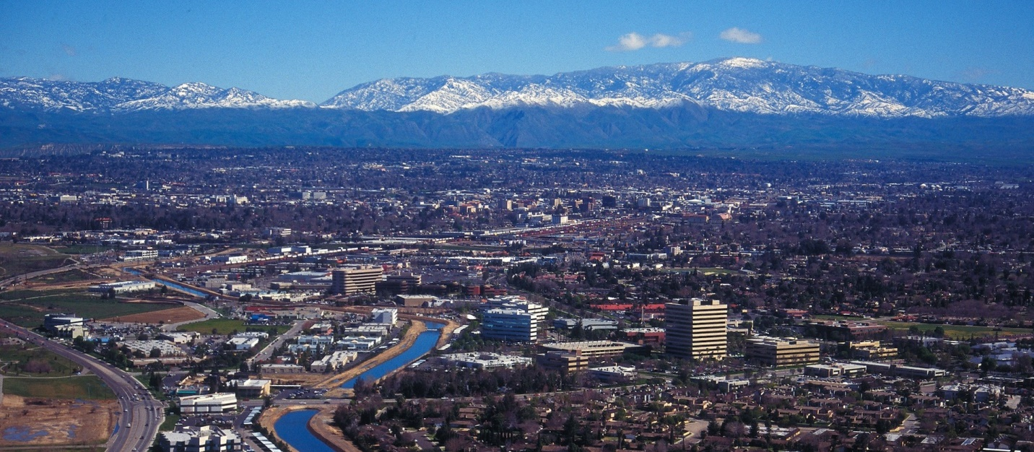
May 2022
The Communicator
KCCVARC Repeater Frequencies
145.150 | minus | 100.0 | Breckenridge Mt.
146.910 | minus | 100.0 | Grapevine Pk.
224,060 | minus | 100.0 | Breckenridge Mt.
443.900 | plus | 100.0 | Low level North of Town
52.780 | minus | 82.5 | Grapevine Pk. | Off the Air - Storm Damage

President: Larry Callahan KF6JOQ
1st VP: Dustin Carpenter, KC0AZW
2nd VP Larry Bragg, N6LWB
Secretary: Scott Royer, KM6RLD
Treasurer: John Stumm, KG6ZBN
Directors:
Paul Ball, KN6FVI
Glen Del Tour, WB8DTJ
Steve Holmes, KM6POI
Net Chief
Neal Janzen, N6YGG

April Meeting
The April meeting convened at Round Table Pizza and it turned out to be a great venue. We saw several new faces in attendance as well as familiar ones. We only had 4 board members so the board was unable to address any club business.
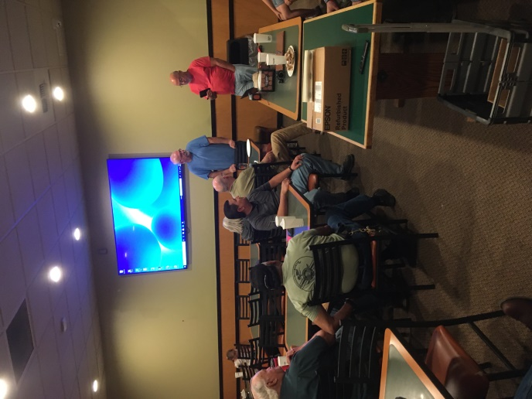
President Larry KF6JOQ spent a lot of time getting his laptop to connect to the parlor's big flat screen. It all paid off come meeting time for Terry (N7AJ) Godley's presentation on Parks On The Air (POTA). The presentation came off without a hitch. Having access to the internet was an added boon.
After the program, there was discussion regarding Field Day this coming June 25 and 26. Plans for the activity will be the topic for May 26 meeting.
Larry, N7LWB, was the recipient of the raffle prize, a nice dual band antenna for 2 meter 440. The antenna will permit remote placement when using a hand held transceiver.
A second antenna was won by a guest, whose name was not available at the time of publication. We will keep Round Table in mind for future meetings.
(Thanks to John, KG6ZBN, for the report on the meeting.)

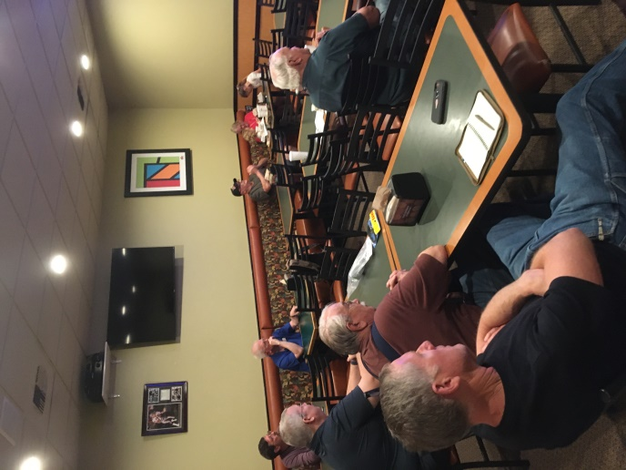
-BREAK-
Ham of the Month
Checking the archives, John, KG7ZBN, found the following article featuring Ham of the Month, featuring Joe Luque, K6JLL.

Joe’s Ham experience goes way back. Joe served in the US Marine Corp as a communicator in the 60s. He continued to serve in the Marine Reserves for several years continuing his research and development. work.

He had taken part in the development of the AN/PRC 74, something he is especially proud of. The AN/PRC 74 was a field radio used by both the Marines and the U.S. Army.
Joe’s extensive background and experience paved the way to securing his ham tickets. In August of 2007, he obtained his Technician. No grass grew under his feet and two weeks later he took the General and Extra exams. He credits his high school teacher, Paul Luter, K6JAG, as an early inspiration, planting the seeds that ended with the Ham ticket years later.

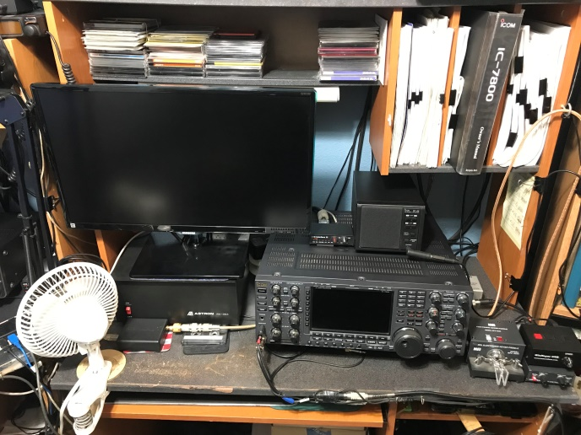
Joe’s shack pictured above

Since receiving his license, Joe has been all in. Besides being an active club member, serving on the board and as president, he’s also helped new hams. He said he partnered with Mark, WI6J doing a good deal of “Elmering”.

They continued the tradition, just as their friend and mentor, Paul served as their “Elmer” the tradition continues.

Joe’s ham shack features his custom built enclosure, housing an impressive array of rigs. Front and center is an Icom IC-7800, with an IC-746 Pro as backup. A special place of honor has been reserved for an IC-735A, his first rig.

An Ameritron AL-1200 provides that extra punch, especially when coupled to his Cushcraft X7 tri-band yagi on a 40 foot tower.
His passion for the hobby has produced some impressive contact numbers. He’s amassed 1064 QSO’s with some 423 QSL’s. He has earned DXCC membership for both phone and mixed, using a Logger 32 to keep track.

It is his primary logging interface, linking with Ham Radio Deluxe as backup. He also uses HRD’s Digital Master 780 module to work his CW contacts, and digital modes, PSK and RTTY. He works virtually all bands, referring to 20 meters as his favorite.

Higher in the spectrum, Joe employs a Kenwood TM-D710 dual bander in his truck, a Yaesu FT-8500 and an Icom V8000 HT, covering VHF/UHF.

Lately he’s been trying out the new crop of Chinese HT’s on the market. A lot of us are buying them as well, inexpensive as they are.
Joe is truly a dedicated and knowledgeable ham. It was a pleasure to interview him.

HF Band Activity
If you are looking for that rare DX station or trying to complete WAC, here is what you might expect to see on the HF bands.
80m-40m | Poor reception during the day
30m-20m | Poor reception during the day
17m-15m | Good reception during the day
12m-10m | Good reception during the day
80m-40m | Good reception during the night
30m-20m | Good reception during the night
17m-15m | Good reception during the night
12m-10m | Poor reception during the night
There are a number of websites dedicated to monitoring and reporting on solar activity and providing information on the impact on DX.
There are many local discussions regarding digital modes, especially FT8. A lot of DX contacts are being made using low power. Check out some of the digital modes and see what is happening.
If you have questions about digital modes, check in on the Tech Net Tuesday on the 145.150 repeater. The net starts Tuesday evenings at 1900. There are some folks checking in regularly who are knowledgeable about the process.
On average, the number of sunspots reaches a maximum every 11 years, but the period has varied from 7 to 17 years. The first cycle to be completely and scientifically observed began in 1755; we know it as Cycle 1.

-BREAK-

From ARRL
Just a reminder, the FCC has imposed fees for license applications, renewals and changes. . The FCC released a Public Notice on March 23, 2022, stating that the amateur radio application fees, including those associated with Form 605 application filings, are effective on April 19, 2022. The Federal Communications Commission's authority to impose and collect fees is mandated by Congress.
The $35 application fee will apply to new, renewal, rule waiver, and modification applications that request a new vanity call sign. The fee will be per application. A problem with the FCC website caused some problems but, according to the latest information, the website is up and running.
For those who are contemplating testing the
VECs and Volunteer Examiner (VE) teams will not collect the $35 fee at exam sessions. New and upgrade applicants will pay the $15 exam session fee to the ARRL VE team as usual.
The $35 application fee is paid directly to the FCC by using the CORES Payer FRN System (easier to use) or the CORES FRN Registration system (CORES - Login). VEC and VE team licensing procedures will not change.
-BREAK-

ARRL Code Practice
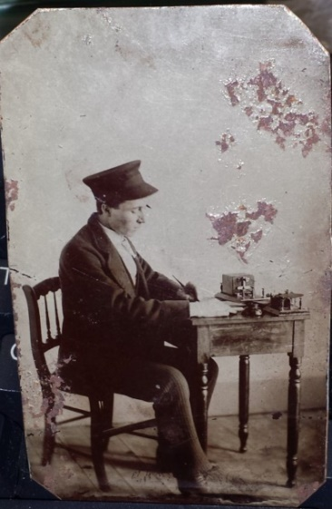
CW is time tested and could be considered the very first digital mode. Instead of ones and zeros CW uses dots and dashes.
There is a lot of CW activity on the bands. Many hams are using automatic keyers and the like but for those of use who plod along at around 10 or 13 WPM, there are plenty of people who will respond to your CQ. Give it a try!
ARRL has made practice sessions available for those for who someday has arrived. If you are interest you can find W1AW on these frequencies at 1300, 1600 and 1900 local time.
Frequencies are 1.8025, 3.5815, 7.0475, 14.0475, 18.0975, 21.0675, 28.0675, 50.350, and 147.555 MHz.
Slow Code = practice sent at 5, 7-1/2, 10, 13 and 15 words per minute (wpm).
Fast Code = practice sent at 35, 30, 25, 20, 15, 13 and 10 wpm. Code bulletins are sent at 18 WPM.
-BREAK-
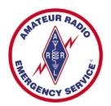
Western Kern County ARES

Western Kern County ARES holds a net on the W6LIE repeater on 145.150 at 1900 local time, Monday evenings. The participants will move off to simplex frequencies in order to test the effectiveness and range of simplex communications.
The third Monday of the month ARES stations will be directed to a specific area control’s assigned frequency. All stations will be asked to check in with the area control and list their availability. The recent tests have been successful and have provided information about the effectiveness of using simplex during emergencies.
Arly, N6INT, acted as net control during the most recent test. Most stations were able to check in directly with Arly. A couple of weak stations required a relay to net control
The 2 meter SSB continues to be very active and expands the reach of VHF. Stations that are capable of VHF SSB are encouraged to check in on 144.225.
Richard, KK6RJR, monitors 146.415 during the Tuesday evening tests, including C4FM. Those who have the capability to transmit and receive using this mode can check in with Richard and test their gear.
ARES is still looking for folks willing to operate as net control. If you are interested advise net control during the Monday evening net or forward an email to KC6EOC@gmail.com
ARES is open to amateur radio operators interested in supporting their community in times of emergencies. If you are interested in participating, check in on the net. There is also an application available on the W6LIE web site.
For more information about ARES please send an email to WKCARES@GMAIL.COM.
-BREAK-

Heard on the Band
One day, a husband was pondering and considering all of the tasks his wife performed around the house, caring for the children, doing laundry, cooking the meals. He began to feel a little guilty and decided that it would be prudent to cultivate domestic harmony with a nod toward her efforts.
He stopped at a florist on the way home from work and purchased a huge bouquet of roses. He then stopped at an upscale candy maker and purchased a very expensive box of chocolates.
Next he located a vintner and asked for their most expensive bottle of champagne. He loaded all of his purchases into the car and headed home, visualizing the anticipated response from his better half.
He pulled into the driveway and unloaded his purchases, struggling to maintain control of his burden. He walked up to the front door of the home, shifted the items around so he could retrieve his house key.
At that moment the Mrs. flung open the door, looked her husband in the eye and burst into tears, not at all the expected response.
“What on earth is the matter, dear.”, the puzzled spouse inquired, still trying to maintain control of gifts he bought.
“This is just a perfect way to end that day!”, she lamented. “First thing this morning the washing machine broken down and flooded the house. I just got the water cleaned up and the roast I had in the oven was burnt and the house was filled with smoke.
“I managed to clear out the smoke and was in the middle of trying to get something together when the children came home and little Johnny got detention and is failing math. Our daughter spilled nail polish on the new living room carpet.
“And now, to top it all off, you come home drunk!”
Sometimes we just can’t win…

Upcoming Events
The May meeting is scheduled for the 26th, at the Veteran’s Hall on Ridge Road. The board will meet at 6:30pm, with the general meeting to follow. The general meeting is scheduled to begin at 7:30PM.
VE testing will be offered June 8. For more information please contact Larry Callahan, KF6JOQ. If you would like to test on another date, please contact Larry and he may be able to make arrangements for an earlier date.
-BREAK-
Looking for Stuff!
Hey! Bet you didn’t know that you have an editorial staff for The Communicator, did ya! Currently it is a staff of one. But we have members out there that might have a topic or two that could be of interest to the membership.
So if you have an article you would like to submit or photos from past or current events please let me know and we can set them up for publishing. This is your newsletter. It should reflect the interests of the members.
73!
-BT-

